**UML Diagram**

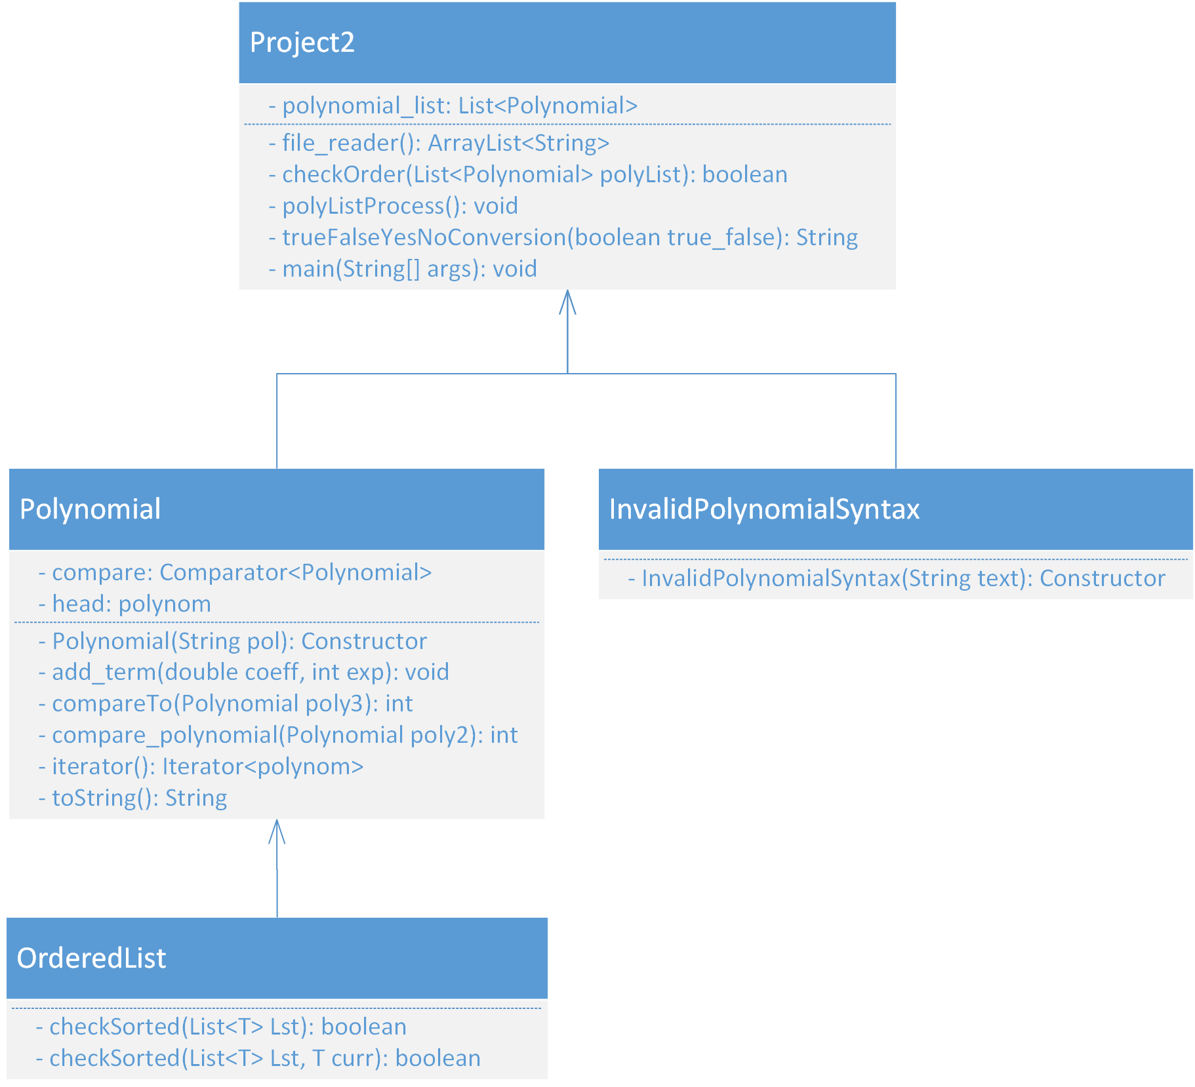

**Lessons learned**

I discovered two things in this mission. I learned how to evaluate objects by using the comparator class. I also discovered how nested classes can be useful in a class. It was much simpler to put the nested classes inside one file, instead of writing several class files.